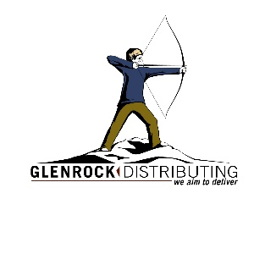
GLENROCK DISTRIBUTING
16358 E 33rd Dr, 6-15, Aurora, CO 80011 / 303-761-8453 / glenrockdistributing.com

ICE WHITE WALL TILE
10x16 matte / 10x16 glossy
